

**MASENO UNIVERSITY**

**DEPARTMENT OF COMPUTER SCIENCE**

**REPORT ON ATTACHMENT AT NZOIA SUGAR COMPANY FOR THE PERIOD OF MAY- JULY 2024**

**STUDENT NAME: PATRICIA NALIAKA KUBENDE**

**REG NUMBER : CCS/00054/021**

**Course title: Industrial attachment Course code: CCS 399**

An attachment report submitted to the School of Computing Sciences in partial

fulfilment of requirements of the award of Degree in BSc. Computer Science at Maseno University

July 2024

# 

# Declaration

I, **Patricia Naliaka Kubende**, a student of Computer Science at Maseno University, hereby declare that this industrial attachment report is my original work. This report is the result of my own efforts and experiences during my attachment period at Nzoia Sugar Company. All information obtained from other sources has been duly acknowledged in the report.

This report has not been submitted to any other institution for any academic qualification or award.

**Signature:** ……………………………………….…………………………………….....

**Academic Supervisor:**

Name: ……………………………………….…………………………………….....

Signature: ………………………………………………………………………….....

Date: …………………………………….....…………………………………….....

**Field Supervisor:**

Name: …………………………………….....…………………………………….....

Signature: …………………………………...…………………………………….....

Date: …………………………………….....…………………………………….....

# Dedication

This report is dedicated to my family for their unwavering support and encouragement throughout my academic journey.

To my lecturers and mentors at Maseno University, whose guidance and knowledge have been instrumental in shaping my educational path.

To the staff and management at Nzoia Sugar Company, whose support and mentorship during my attachment period have been invaluable in providing practical insights and professional development.

Lastly, to my friends and colleagues, whose companionship and motivation have made this journey enjoyable and fulfilling.

# Acknowledgement

I would like to express my sincere gratitude to everyone who supported me during my industrial attachment at Nzoia Sugar Company.

Firstly, my heartfelt thanks go to the management and staff of Nzoia Sugar Company for providing me with this invaluable opportunity and for their continuous guidance and support throughout my attachment period. Their willingness to share their knowledge and experiences significantly enhanced my learning process. I would like to thank my field supervisor Mr. James Ogada for valuable guidance, support and encouragement throughout the attachment period.

I am immensely grateful to my academic supervisor, Mrs. Vivian Oloo, at Maseno University for her unwavering support, encouragement, and insightful advice. Her mentorship played a crucial role in the successful completion of this report.

I would also like to acknowledge my family and friends for their constant encouragement and understanding during this period. Their emotional support and belief in my abilities have been a great source of motivation.

Lastly, I extend my appreciation to my colleagues and fellow interns at Nzoia Sugar Company for their camaraderie and collaborative spirit, which made the attachment period both productive and enjoyable.

Thank you all for your valuable contributions.

# Abstract

This report presents the experiences and insights gained during an industrial attachment at Nzoia Sugar Company. The attachment involved working in various departments, with a focus on IT operations, data management, and system development. Key areas explored include the company's history, structure, and technological infrastructure. The report highlights the working conditions, technologies used, and procedures employed in daily work done. It also assesses the skills and qualifications gained, the challenges faced, and the impact of the attachment on future career plans. The conclusion offers recommendations for both Nzoia Sugar Company and future interns.

Table of Contents

Declaration ii

Dedication iii

Acknowledgement iv

Abstract v

CHAPTER ONE: INTRODUCTION 1

1.1 Overview of Industrial Attachment 1

1.2 Objectives of Industrial Attachment 1

1.3 Scope of Industrial Attachment 2

1.3 Background of Organization 3

1.3.1 Geographical Background 3

1.3.2 Historical Background 4

1.4 Mission 4

1.5 Vision 4

1.6 Mandate 4

1.7 Core Values 4

1.8 Organizational Structure 5

1.8.1 DESCRIPTION OF THE DEPARTMENTS 6

CHAPTER 2: THE ICT DEPARTMENT 8

ICT Department of Nzoia Sugar Company 8

Functions and Responsibilities 8

1. IT Infrastructure Management: 8

2. Technical Support: 8

3. Enterprise Resource Planning (ERP) System: 8

4. Strategic Planning and Innovation: 9

Organizational Structure 9

CHAPTER 3: ATTACHMENT EXPERIENCES 12

3.1 General Activities Undertaken 12

3.2 Specific Activities Undertaken 12

3.3 Analysis of Learnt Knowledge and Applied Skills 14

3.4 Profile of Skills and Competencies Gained/Acquired 14

3.5 Observations and Critique 16

3.5.1 What Learnt 16

3.5.2 What Not Learnt 17

3.5.3 Relevance of Experience to the Training 18

3.6 Challenges Encountered During the Attachment Period 18

3.7 How I Overcame the Challenges 19

CHAPTER 4: SUMMARY, CONCLUSIONS AND RECOMMENDATIONS 20

4.1 Summary 20

4.2 Conclusions 21

4.3 Recommendations 22

CHAPTER 5: REFERENCES 23

Appendices 24

**LIST OF FIGURES**

Figure 1: Nzoia sugar company aerial view 3

Figure 2:NSC organization chart 5

**List of Abbreviations**

* **ICT**: Information and Communications Technology
* **NSC**: Nzoia Sugar Company
* **IDB**: Inter-American Development Bank
* **AMS**: Agriculture Management System
* **CPU**: Central Processing Unit
* **IT**: Information Technology
* **OTDR**: Optical Time Domain Reflectometer
* **ODF**: Optical Distribution Frame
* **MI**: Marketing Intelligence
* **RJ45**: Registered Jack 45 (Ethernet connector)
* **SAP**: Systems, Applications & Products
* **D-link**: A brand of network equipment
* **MI**: Marketing Intelligence

# CHAPTER ONE: INTRODUCTION

## 1.1 Overview of Industrial Attachment

Industrial attachment, is a structured learning experience designed to provide students with practical exposure in their field of study. It bridges the gap between theoretical knowledge gained in academic settings and realworld applications in industry. Typically, industrial attachments are mandatory components of many academic programs, allowing students to apply their classroom knowledge to practical situations in professional environments. This handson experience is invaluable for enhancing students' skills, understanding industry practices, and preparing them for future careers.

## 1.2 Objectives of Industrial Attachment

The primary objectives of industrial attachment include:

* **Skill Development**: To develop practical skills and competencies relevant to the student's field of study.
* **Experiential Learning**: To provide handson experience in a realworld work environment.
* **Professional Development**: To enhance professionalism, work ethic, and adaptability to workplace dynamics.
* **Industry Exposure**: To gain insights into industry practices, trends, and challenges.
* **Networking**: To build professional networks and relationships with industry professionals.
* **Career Preparation**: To prepare students for future employment opportunities by equipping them with practical experience and industryspecific knowledge.

## 1.3 Scope of Industrial Attachment

The scope of an industrial attachment includes:

* **Work Assignments**: Involved tasks and projects that align with the student's academic background and career interests.
* **Supervision**: Guidance and mentorship provided by experienced professionals to support learning and development.
* **Learning Outcomes**: Defined goals and objectives that students are expected to achieve during their attachment period.
* **Evaluation**: Assessment of performance and achievements based on predefined criteria, often including feedback from supervisors and reflective assessments by students.

Industrial attachments are structured to maximize learning opportunities and provide a wellrounded experience that prepares students for future roles in their chosen field.

## 1.3 Background of Organization

### 1.3.1 Geographical Background

Nzoia Sugar Company is situated in the western part of Kenya located in Bungoma County, Kenya. Bungoma County, Bungoma South sub-county, 5 Kilometers from Bukembe, off the Webuye Bungoma highway. It is known for its agricultural activities and as a hub for sugar production. The Company serves over 45,000 farmers in the larger Bungoma, Kakamega, Lugari and Malava. It is situated at a latitude of 0? 35’N and a longitude of 34? 40’E, and an altitude of between 14201490 meters above sea level . [1]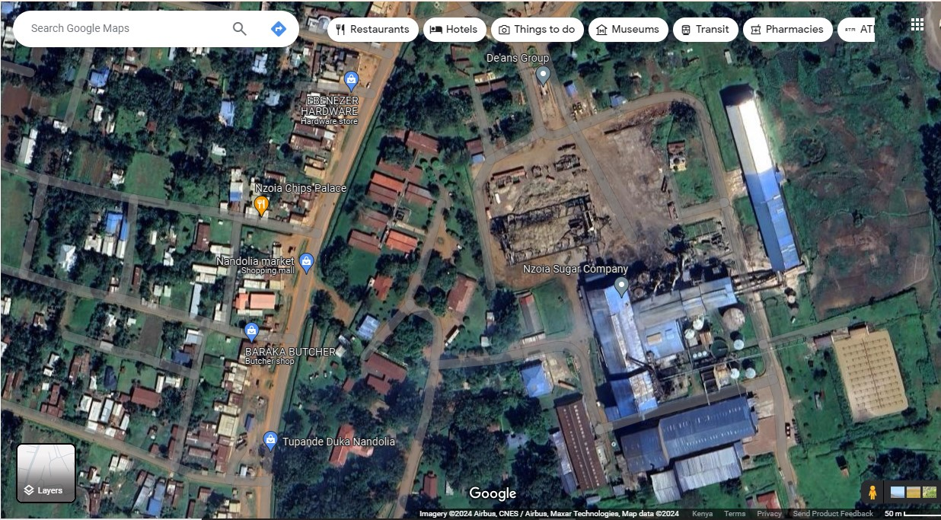

Figure 1: Nzoia sugar company aerial view

### 1.3.2 Historical Background

The Company was established in 1975, under the Companies Act Cap. 486 of the Laws of Kenya with Memorandum and Articles of Association and issued a certificate of incorporation No.C13734 dated 1st August, 1975. The Government is the major shareholder owning 98% of the shares, while Fives Cail and IDB Capital own the remaining 2%.

NSC produces sugar and supports cane production through the provision of extension services to farmers with an extensive Company nucleus cane estate covering 3,600 ha and an

market. [2]

## 1.4 Mission

To efficiently, innovatively and sustainably produce and market sugar and other products in a clean and safe environment to the satisfaction of all stakeholders

## 1.5 Vision

To be globally competitive in production and marketing of sugar and other products.

## 1.6 Mandate

To manufacture sugar and coproducts from sugarcane.

To establish and manage sugarcane plantations and assist others to do so.

## 1.7 Core Values

* Customer focus
* Integrity
* Professionalism
* Innovation and creativity
* Teamwork and mutual respect
* Commitment and hard work

## 1.8 Organizational Structure

The organization structure is hierarchical, with the Board of Directors at the top, followed by the Managing Director, departmental heads, and various operational staff.This information is crucial for understanding how the company is managed and how various functions are organized to achieve its strategic objectives. The primary customers of NSC are local sugar consumers, industrial buyers, and wholesalers. The company also serves local farmers who supply sugarcane. NSC employs a diverse workforce comprising managerial, technical, and support staff organized into various departments.

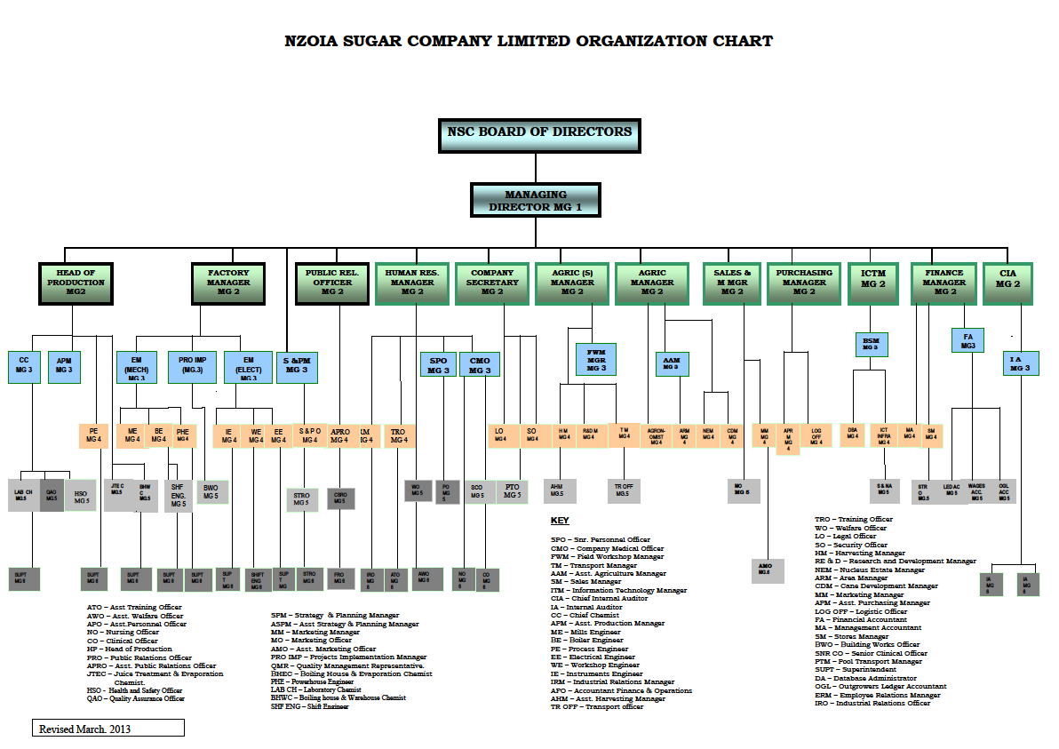

Figure 2:NSC organization chart

### 

### 1.8.1 DESCRIPTION OF THE DEPARTMENTS

**Agriculture department**

It is responsible for sugarcane farmer recruitment, land preparation and bush clearing, ploughing, surveying, harrowing, furrowing, farmers extension and education services and handling of complaints and enquiries.

**Human Resource department**

This is responsible for recruitment and selection, response to inquiries, industrial attachment,

educational tours, provision of catering services at the company guest house, handling

complaints and inquiries and emergency services at company clinic which includes: examination, first aid, referral and or letter of undertaking.

**Sales and Marketing department**

It is in charge of purchase of sugar, selling of molasses, handling of customers complaints and

inquiries.

**Agricultural services department**

It is responsible for cane harvesting and transport, handling customer complaints and inquiries.

**Projects department**

Construction and maintenance of roads, installation and repair of culverts.

**Public Relations department**

It handles resolution of public complaints, handling media inquiries, implementation of CSR

projects.

**Finance department**

It is in charge of suppliers’ payments, farmers’ payments, contractors’ payments, handling

customer complaints and inquiries.

**Factory department**

It is responsible for milling cane, deliver juice to production for processing, generate and supply

steam, pump water from river Kuywa, maintain company buildings, implement all company

projects to timely completion, ensure statutory plant inspection is timely done, automation of

factory equipment and processes.

**Strategy and Planning department**

It coordinates strategic planning, work planning, performance contracting, monitoring, evaluation and reporting, analysis of key performance indicators, coordinate risk management

and establishment of Service Level Agreement (SLAs)

**Production department**

It deals with laboratory analytical services, packaging and branding of sugar, industrial and

domestic water supply, treatment of factory effluent, factory performance reports, handling

complaints and inquiries. [3]

# CHAPTER 2: THE ICT DEPARTMENT

## ICT Department of Nzoia Sugar Company

The Information and Communication Technology (ICT) Department at Nzoia Sugar Company plays a critical role in supporting the company's operations through the deployment and management of technology resources. Here is a detailed description of the ICT department:

## Functions and Responsibilities

### 1. IT Infrastructure Management:

* Network Management: Ensuring robust and secure network infrastructure to support companywide communications and data transfer.
* Hardware and Software Maintenance: Overseeing the installation, configuration, and maintenance of computer systems, servers, and software applications.
* Data Center Management: Managing the company’s data centers, ensuring high availability and reliability of servers and storage systems.

### 2. Technical Support:

Help Desk Services: Providing technical support and troubleshooting for employees, addressing issues related to hardware, software, and network connectivity.

User Training: Conducting training sessions for employees to enhance their technical skills and ensure efficient use of ICT resources.[4]

### 3. Enterprise Resource Planning (ERP) System:

ERP Implementation and Support: Managing the implementation and maintenance of the ERP system, which integrates various business processes including production, finance, human resources, and supply chain management.

### 4. Strategic Planning and Innovation:

IT Strategy Development: Formulating and implementing the company's IT strategy in alignment with its overall business objectives.

Technology Upgrades: Identifying and implementing new technologies to improve operational efficiency and drive innovation.

## Organizational Structure

The ICT Department is typically structured to include several key roles and subdepartments, such as:

**ICT Manager**: Heads the department, responsible for strategic planning, oversight, and ensuring that ICT initiatives align with the company’s goals.

**Network Administrator:** Manage the network infrastructure, ensuring connectivity and security.

**System Administrator**: Oversee servers, databases, and ensure smooth operation of all IT systems.

Importance to the Company:

Enhancing Operational Efficiency:.

Supporting Decision Making

The ICT Department's continuous efforts to integrate advanced technologies and improve IT services play a vital role in the success and growth of Nzoia Sugar Company.[5]

**Importance to the Company**

The ICT Department at Nzoia Sugar Company is crucial for:

* **Enhancing Operational Efficiency:** By automating processes and providing reliable IT services, the department helps improve overall productivity.
* **Supporting Decision Making:** Through data management and reporting tools, the department provides valuable insights for strategic decision-making.
* **Ensuring Business Continuity:** By maintaining robust IT infrastructure and implementing security measures, the department ensures uninterrupted business operations.

The ICT Department's continuous efforts to integrate advanced technologies and improve IT services play a vital role in the success and growth of Nzoia Sugar Company.

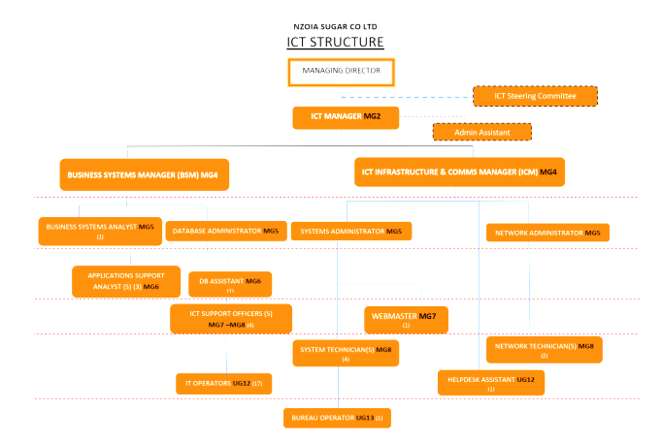

# CHAPTER 3: ATTACHMENT EXPERIENCES

## 3.1 General Activities Undertaken

During my industrial attachment at Nzoia Sugar Company, I was engaged in a variety of activities that provided a broad understanding of the company's operations. These activities included:

**Orientation and Induction**: Getting acquainted with the company’s policies, safety procedures, and operational guidelines.

**Department Rotations**: Working in different departments to understand their functions and contributions to the company.

**Documentation and Reporting**: Maintaining records of daily tasks, progress reports, and documentation of technical processes.

## 3.2 Specific Activities Undertaken

In addition to general activities, I was assigned specific tasks that were directly related to my field of study in Computer Science.

* **Creating a website using WordPress** I was tasked to develop a fully functional website. I utilized XAMPP as a local server environment to host the website and WordPress as the content management system.
* **Backup administration** I was tasked with the responsibility of ensuring data integrity through regular backups
* **Making Ethernet cables** I Was involved in a hands on activity which was making of Ethernet cables which are crucial for networking activities. The activities included; cable cutting and stripping, crimping (arranging the wires according to the T568A or T568B standard and using a crimping tool to attach the RJ45 connectors), testing.
* **Configuring Nano station m2 loco I** worked on configuring the Nano Station M2 loco, a wireless CPE device, to enhance network connectivity. The tasks involved ; physically setting up the device and connecting it to the network, accessing the devices web interface to configure settings and adjusting settings to optimize signal strength and coverage area.
* **Troubleshooting warehouse network** participated in troubleshooting the network within the warehouse which involved; using diagnostic tools to identify network issues, implementing solutions such as resting devices, reconfiguring network settings and replacing faulty hardware and documentation of the work done.
* **Database Administration and Maintenance:** I assisted in the maintenance of the company's databases, ensuring data integrity and optimizing database performance. Tasks included regular backups, updating records, and troubleshooting database issues.
* **Software Installation and Configuration:** I assisted in installing and configuring essential software used by the company, such as the Agriculture Management System (AMS), SAP Smart Weigh, and antivirus programs. This also included setting up and configuring Nano station devices for network connectivity.

## 3.3 Analysis of Learnt Knowledge and Applied Skills

The attachment provided a practical platform to apply theoretical knowledge gained in the classroom. Key areas of learning and application included:

**Data Management**: Implementing data management principles to ensure the accuracy and security of information.

**Problem Solving**: Developing problem solving skills through troubleshooting and resolving technical issues.

**Project Management**: Applying project management techniques in software development projects.

**Networking Skills**: Enhancing networking skills by setting up and maintaining network systems.

**Communication Skills**: Improving communication skills through interaction with colleagues and team members.

## 3.4 Profile of Skills and Competencies Gained/Acquired

The attachment period was instrumental in developing a wide range of skills and competencies, including:

**Technical Skills**: Proficiency in database management, software development, and network administration.

**Analytical Skills**: Ability to analyze complex problems and devise effective solutions.

**Teamwork**: Enhanced ability to work collaboratively in a team environment.

**Time Management**: Improved time management skills, enabling efficient task completion within deadlines.

**Adaptability**: Increased adaptability to new technologies and working environments.

|  |  |
| --- | --- |
| **Network and troubleshooting** | Ability to identify and resolve network issues using diagnostic tools (e.g., OTDR, power meters). |
| **Database administration** | Proficiency in maintaining and optimizing database performance, including regular backups. |
| **Hardware repair and maintenance** | Skill in diagnosing and repairing hardware issues for computers and printers. |
| **Software installation and configuration** | Competence in installing and configuring enterprise software (AMS, SAP, antivirus). |
| **Server management** | Understanding of server setup, configuration, and monitoring for optimal performance. |
| **Cable management** | Expertise in creating and testing RJ45 cables for network connectivity |
| **Cisco switch management** | Knowledge of configuring Cisco switches using tools like PuTTY and console cables. |
| **User support and help**  **Desk** | Ability to provide technical support and troubleshoot user issues effectively. |
| **Project management** | Experience in planning, executing, and managing IT projects, ensuring successful implementation. |
| **Documentation and reporting** | Competence in maintaining detailed records of IT activities, configurations, and issues. |

## 3.5 Observations and Critique

### 3.5.1 What Learnt

1. **Industry Practices**: Gained insights into industry standards and best practices in IT and data management.
2. **Technology Application**: Understanding the application of various technologies in a real world setting.

* **Database Administration**: Acquired skills in maintaining and optimizing database performance. Learned how to perform regular backups and restore databases when necessary. **Appendix-B** (Smith, J. (2018).)
* **Server Management**: Gained knowledge of server setup, configuration, and monitoring. Learned about the physical and virtual aspects of managing server infrastructure. **Appendix-c**
* **Network Setup and Configuration**: Learned how to create and test RJ45 cables. Gained experience in configuring Cisco switches and setting up network infrastructure. Understood the process of diagnosing and troubleshooting network issues using tools like OTDR and power meters. (Brown, A., & Wilson, P. (2017).)
* **Hardware Maintenance and Repair**: Developed the ability to diagnose and repair hardware issues for computers and printers. Gained hands-on experience in maintaining and upgrading computer components.
* **Software Installation and Configuration**: Learned to install and configure essential enterprise software such as AMS, SAP Smart Weigh, and antivirus programs. Understood the importance of software updates and compatibility.
* **User Support and Help Desk**: Developed skills in providing technical support to users. Learned how to troubleshoot and resolve issues related to system applications and network connectivity.
* **Project Management**: Gained experience in planning, executing, and managing IT projects. Understood the importance of coordination and resource management in project success.
* **Data Management and Security**: Learned about data backup and recovery techniques. Understood the implementation of security protocols to protect sensitive information.
* **Documentation and Reporting**: Developed skills in maintaining detailed records of IT activities, configurations, and issues.

1. **Professionalism**: Importance of professionalism and ethical conduct in the workplace.

### 3.5.2 What Not Learnt

* **Advanced Programming:** Limited exposure to advanced programming concepts and languages.
* **Research and Development**: Minimal involvement in research and development activities within the company.
* **Data Analytics and Business Intelligence**: Did not delve into data analytics tools and techniques or gain experience with business intelligence software for data-driven decision making.
* **IoT (Internet of Things) Implementations**: Did not explore IoT technologies or engage in projects involving IoT devices and their integration into the network.
* **Machine Learning and Artificial Intelligence**: No exposure to machine learning models, artificial intelligence applications, or data science methodologies.

### 3.5.3 Relevance of Experience to the Training

The experience was highly relevant to my academic training, as it provided a practical context for applying theoretical knowledge. The tasks and projects were aligned with the curriculum, enhancing my understanding of core concepts in computer science.

## 3.6 Challenges Encountered During the Attachment Period

Several challenges were encountered during the attachment period, including:

1. Technical Issues: Frequent technical malfunctions with hardware and software required quick troubleshooting and resolution.

2. Time Management: Balancing multiple tasks and deadlines was challenging, requiring efficient time management.

3. Learning Curve: Adapting to new technologies and systems in a short period was demanding.

4. Communication Barriers: Overcoming communication challenges with colleagues from different departments and backgrounds.

5. Limited Resources: Occasionally dealing with limited access to necessary tools and resources.

6. High Expectations: Meeting the high expectations set by supervisors and the company.

7. Data Management: Ensuring the integrity and security of large datasets was complex.

8. Documentation: Keeping up with detailed documentation and reporting of tasks and progress.

9. Network Issues: Occasional network downtimes affected productivity and required immediate attention.

10. Team Coordination: Coordinating effectively within diverse teams and managing collaborative projects.

## 3.7 How I Overcame the Challenges

To overcome these challenges, I adopted several strategies:

• **Seek Guidance**: Regularly consult with supervisors and experienced colleagues to gain insights and support.

• **Effective Time Management**: Prioritize tasks and use tools like calendars and to-do lists to manage time efficiently.

• **Continuous Learning**: Engage in self-study and training sessions to adapt to new technologies and systems.

• **Active Communication**: Improve communication skills by participating in meetings and discussions.

• **Resource Utilization**: Make use of available resources and tools to overcome technical limitations.

• **Feedback and Improvement**: Actively seek feedback and work on areas of improvement.

• **Networking**: Build professional relationships for support and mentorship.

• **Problem-Solving**: Develop strong analytical skills to troubleshoot and resolve technical issues.

• **Resilience and Adaptability**: Stay adaptable and resilient in the face of challenges and changing environments.

• **Documentation**: Keep detailed records of tasks and learnings to track progress and reflect on improvements.

# CHAPTER 4: SUMMARY, CONCLUSIONS AND RECOMMENDATIONS

## 4.1 Summary

The industrial attachment at Nzoia Sugar Company was a profound and educational experience that allowed me to apply my academic knowledge in a practical environment. Throughout the attachment, I was involved in various activities, including IT system maintenance, database management, software development, and network administration. These activities provided a comprehensive understanding of the company’s operations and the integral role of technology in supporting and enhancing business processes.

I faced several challenges, such as technical issues, time management, and adapting to new technologies. However, through proactive learning, seeking guidance, and applying effective problem-solving strategies, I was able to overcome these obstacles. The experience significantly contributed to my personal and professional development, equipping me with essential skills and competencies for my future career.

## 4.2 Conclusions

The industrial attachment at Nzoia Sugar Company met its objectives of providing practical experience, enhancing technical skills, and developing professional competencies. The attachment period allowed me to gain insights into industry practices, understand the application of IT in a real-world setting, and build a network of professional relationships.

The challenges encountered and overcome during the attachment have built resilience and adaptability, which are crucial traits for my future career. The experience has also influenced my career aspirations, providing clarity and direction for my professional development in the field of computer science, particularly in data science and machine learning.

## 4.3 Recommendations

Based on my experiences and observations, I offer the following recommendations:

For Future Interns:

1. Active Engagement: Engage actively in all assigned tasks and seek out additional learning opportunities to maximize the benefits of the attachment period.

2. Proactive Learning: Take the initiative to learn and adapt to new technologies and systems.

3. Seek Feedback: Regularly seek feedback from supervisors and colleagues to identify areas for improvement and gain a better understanding of professional expectations.

4. Maintain Documentation: Keep detailed records of tasks, projects, and experiences to facilitate learning and provide a basis for the final report.

5. Build Professional Relationships: Network with colleagues and mentors to build professional relationships that can be valuable for future career opportunities.

For Nzoia Sugar Company:

1. Enhanced Training Programs: Implement more comprehensive training programs covering advanced topics in programming, data analytics, and emerging technologies.

2. Research Opportunities: Provide opportunities for interns to engage in research and development activities to foster innovation and deeper learning.

3. Regular Feedback Sessions: Conduct regular feedback sessions to ensure continuous improvement and address any challenges interns may face.

4. Resource Accessibility: Ensure that interns have access to the necessary tools and resources

# CHAPTER 5: REFERENCES

• Nzoia Sugar Company Ltd. (n.d.). Sweetening Kenya since 1978. Retrieved from <https://www.nzoiasugar.co.ke/>

• Smith, J. (2018). "Database Management Systems." 3rd Edition. New York: McGraw-Hill Education.

• Brown, A., & Wilson, P. (2017). "Networking Fundamentals." 2nd Edition. Boston: Pearson Education.

• Johnson, M., & White, R. (2016). "Effective Communication in the Workplace." London: HarperCollins Publishers.

• Jones, K., & Green, L. (2019). "Software Development Practices." 4th Edition. San Francisco: O'Reilly Media.

• Industrial attachment logbook (2024) https://github.com/PatriciaKubende/Industrial_Attachmet_Logbook

# Appendices

Appendix A:

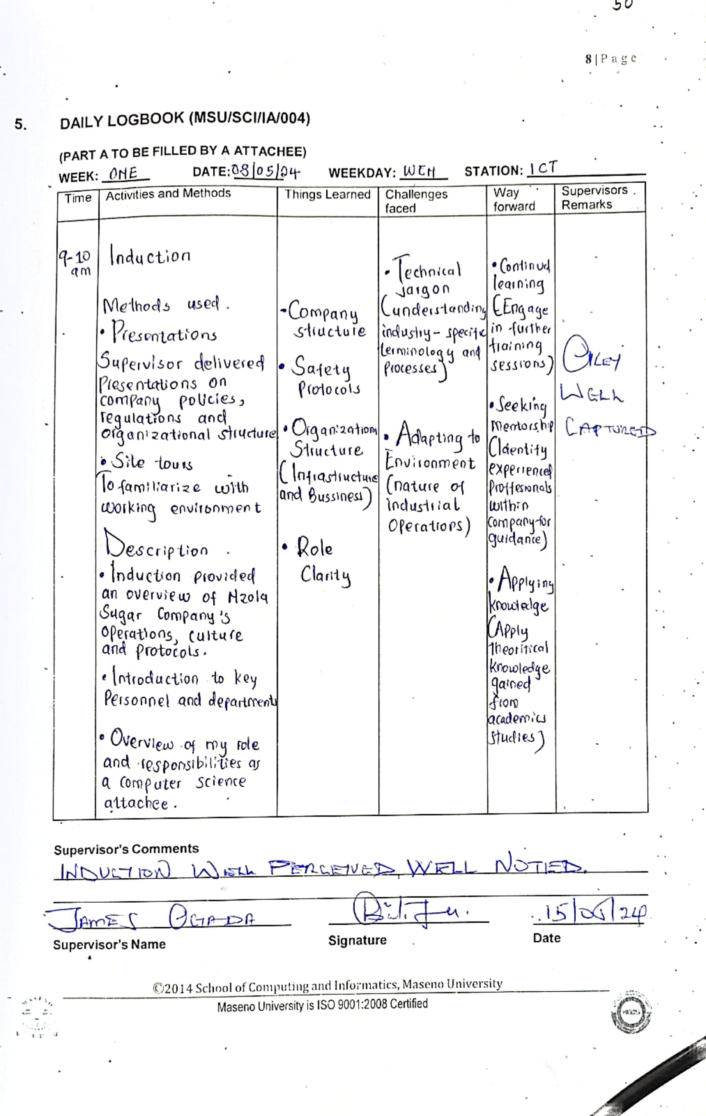

Appendix-B

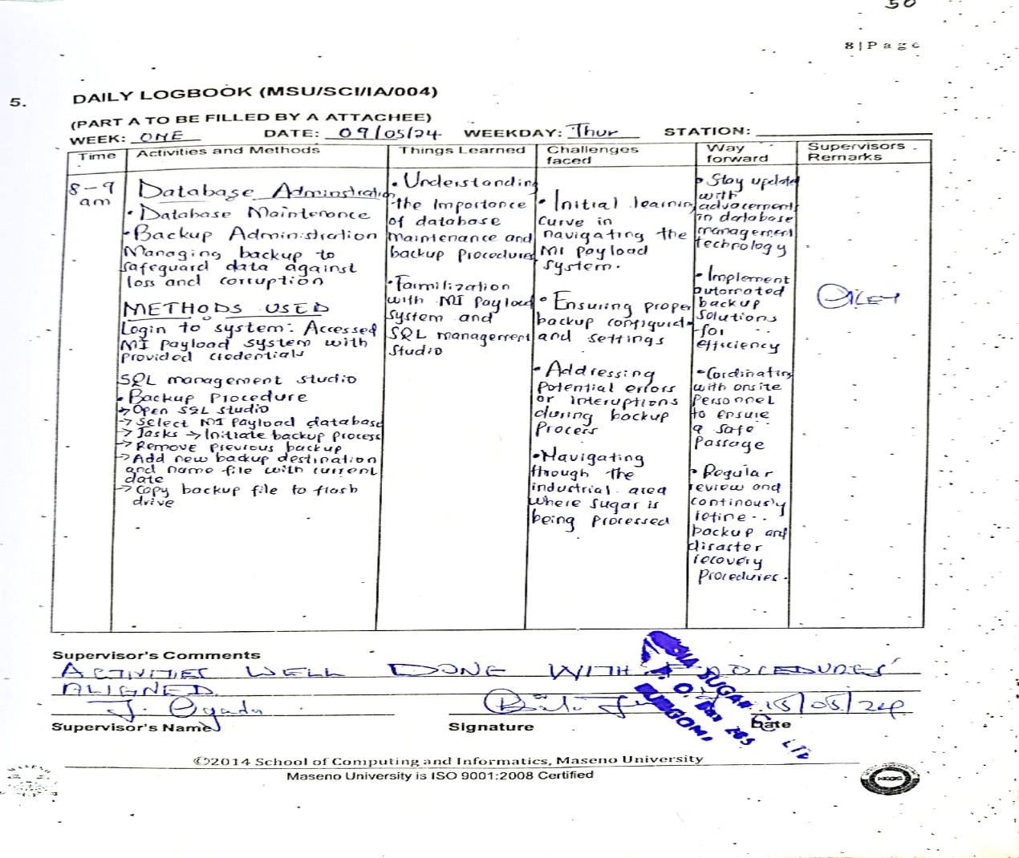

Appendix-C

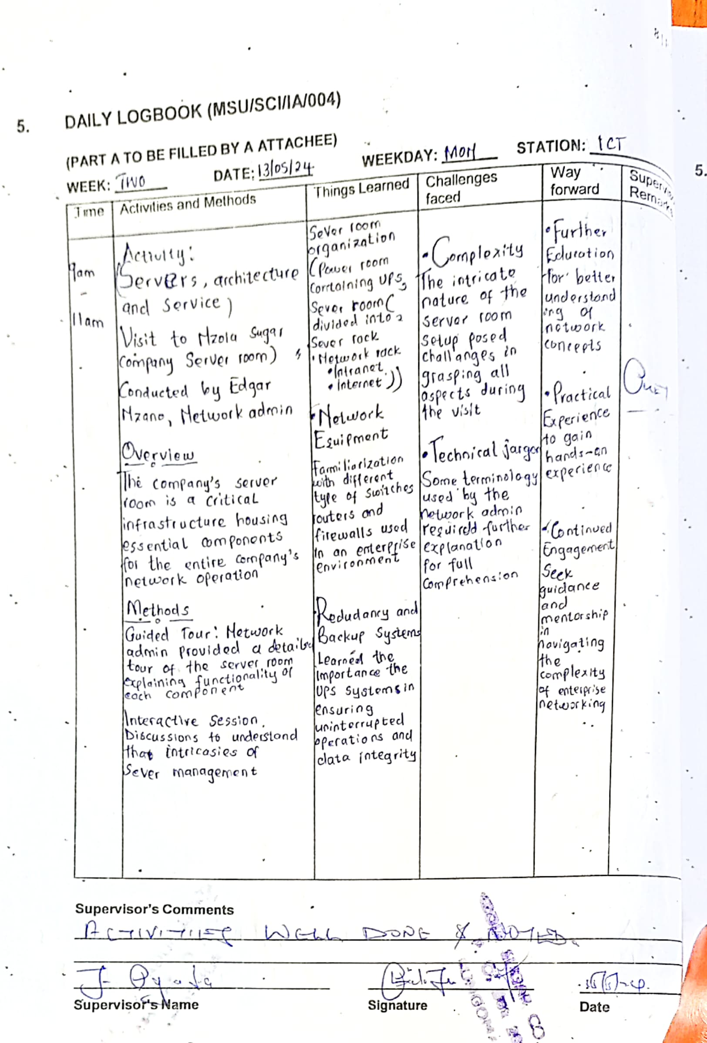

**CONFIRMATION**

**INDUSTRIAL SUPERVISOR**

NAME..........................................................................................................................

DATE...............................................SIGNATURE...................................................

**HEAD OF DEPARTMENT**

NAME..........................................................................................................................

DATE...............................................SIGNATURE...................................................

**TRAINING OFFICER**

NAME..........................................................................................................................

DATE...............................................SIGNATURE...................................................

RUBBERSTAMP.....................................................

1. “Nzoia Sugar Company Location.”
2. “Nzoia Sugar Company Ltd. – Sweetening Kenya since 1978.”
3. {Nzoia Sugar Company}
4. “Nzoia Sugar Company Help Desk.”
5. {APPENDIX A}